How to create a 70-20-10 development plan

Most of the time, the audience for the Sprout Labs blog posts are learning and development people. I often talk about the role of managers in learning and this blog is firmly focused on helping them implement the 70-20-10 learning model in their team.

In this post I’m wearing two hats. On the one hand I’m working with an organisation on various learning issues, and on the other I’m managing my team here at Sprout Labs, implementing new ways of learning. From both viewpoints it’s apparent that making continuous learning actually happen in the workplace is not easy.

Typically, when an organisation starts with the 70-20-10 learning model there is a lot of focus on informal learning (the 70). This is partly because informal learning is something that learning and development teams haven’t been great with in the past. The risk with such a focus on experiential learning is that it doesn’t happen merely by ‘doing’, it happens when someone articulates and reflects upon what they have learned. Maximising the opportunities for your team members to articulate and reflect helps to build a culture of continuous learning and improvement in the team.

Imagine for a moment that one of your team members, Noah, has been struggling with project management skills. Your organisation has been using the Prince project methodology but Noah is interested in the possibilities that agile project methodologies have to offer.

Step 1: Which design pattern describes the learning problem?
The Finnish academic Päivi Tynjälä (Tynjälä, 2010) has described the functions of learning as:
- Introducing new knowledge to an organisation
Introducing new knowledge usually involves classic activities of learning and development, such as organising a course that is meant to change behavior.
- Sharing existing knowledge and practice of an organisation
Sharing existing knowledge and practice is another of the classic activities of learning and development. It’s what happens during an induction or onboarding program. It’s the process of showing ‘how it’s done here’. The 70-20-10 learning model can be powerful for sharing knowledge.
- Creating new knowledge and new practice
Creating new knowledge and practice is a relatively new function of learning and development. It’s about building a culture of continuous learning and constructing, supporting employees to learn and enabling the organisation to transform itself. (Pedler, Burgogyne and Boydell, 1997)

These functions are useful because they can be used to sort learning and performance issues into one of these three areas, and then one of the design patterns outlined below can be applied. Design patterns are repeatable ways of solving problems.

 | Design patterns
Introducing new knowledge to an organisation | Begin with a formal learning activity (10). This new knowledge is then ‘transferred’ into workplace behaviour, through a range of processes including reminders, social learning, and supporting the new practices by other changes in the workplace.
Sharing existing knowledge and practice of an organisation | This design pattern can start with social learning (20) and informal learning (70). If the learning need is shared, it means the learner may find someone else in the organisation who is already competent in this area, and can then mirror them or document their processes.
Creating new knowledge and new practices | Creating new knowledge and new practices are more focused 20 and 70 components of the model.

In Noah’s case – he wishes to improve his project management skills through agile methodologies – we’re looking at new knowledge for the organisation. There are people who are currently doing project management within the organisation, but they are not using agile methods. It could still be useful for Noah to spend time with the people doing project management inside the organisation, to gain an understanding how they work, but the solution to Noah’s learning challenge will come from a combination of design patterns.

Step 2: Designing the program
The next stage is to work with Noah to design his learning plan. This is a combination of deciding on the type of activities and the way in which they are ordered. Instructional designers call this ordering process ‘sequencing’. Noah’s learning needs are a hybrid of sharing and bringing new knowledge into the organisation. It makes sense to first gather an understanding of project management basics from his peers before he begins to learn about agile methods.

The sharing design pattern

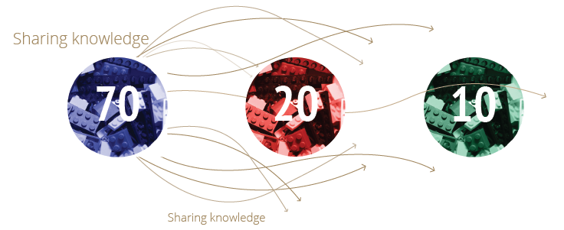

This design pattern begins with informal learning. There is often a blurring between informal (70) and social (20) learning in the model, but some useful techniques are:

Process walk-through

Parallel practice

Diagnosis

Shadowing

Interview

Review

Mirroring

Mentoring

Exchanges

Job aid

Research

Delegation

These are described in more detail in our Build Expertise ebook.
As Noah’s manager, one of the most valuable things you might do is help him to articulate and reflect on what he has learned. This might come through simple questions like:
- ‘What did you learn from …’
- ‘How did you go with …’

If the learning problem can be solved through sharing there often isn’t a need for a formal component.

When thinking about a team member’s learning problem it’s useful to ask yourself whether someone in the team, or elsewhere in the organisation, is doing this already. In Noah's case there are a few people in the organisation involved in project management so it would be useful for him to spend some time with them.

The new knowledge design pattern

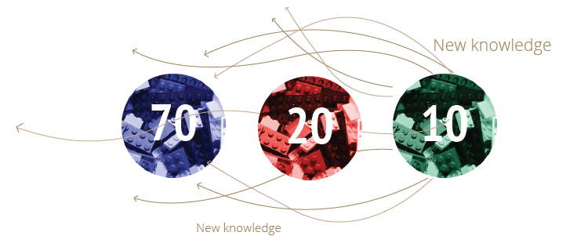

The new knowledge design pattern is what training and learning has traditionally been about. Bring in new skills, knowledge and behaviours into an organisation. A useful way of incorporating the 70-20-10 approach is to think about this as ‘learning transfer’. Learning transfer is about making sure what an employee has learned in a formal training program is transferred into behavioural change.

This design pattern starts in the 10 and then moves into the 70 and 20. It uses social and informal learning to support and enable your team member’s new behaviours. Approaches to supporting and enhancing informal learning include reminding the learner about the content after the program is finished, spacing the learning over a period of time, and tracking progress. One of the keys to making sure behaviour change happens lies in making both yourself and the learner accountable – going to a training course is often fun, but making the change back in the workplace can be hard.

If you're sending someone on a training program it’s important to have a conversation with your team members along the lines of ‘What will be the impact of the program on the individual, on the team, and on the processes we use?’

In Noah’s case the development plan might begin with this process of mapping the impact. Then he might do a course on agile project management. Once the formal learning is done, he might come back and run a short presentation for his team about what he learned, and follow this up with running his own (small) agile project.

Because agile project management is new to the organisation, Noah won’t have peers to connect with. As his manager you would need to encourage him to build a network outside of the organisation with others who are interested in agile project management. Hopefully the training provider already has such a network in place; if they don’t, a good place to find one is http://www.meetup.com.

The generating new knowledge design pattern – innovating

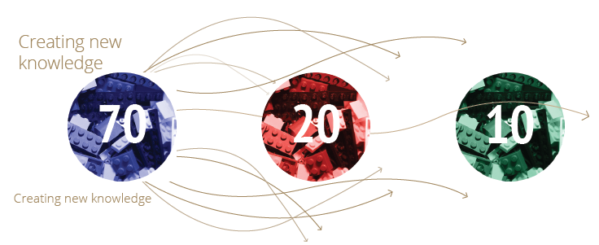

The third pattern is relatively new to learning and development. It’s not about organising training, but about developing the right environment for a culture of learning and innovating to happen. A culture of learning eventuate when there is a continuous process of improving. Work and learning are integrated. As a manager, this means you need to be constantly asking what is working and what is not working, and working with your team to come up with solutions for those problems.

Innovation is much more than just brainstorming ideas. It can be about doing research to develop new insights into how the various aspects of an organisation operate. It can also be about micro changes and improvements that are a continuous part of work. This focus on continuous learning and improvement is where the real power of the 70-20-10 model lies.

As a learning design pattern it firmly starts in the 70. The process needs to be collaborative. If one of your team is leading this type of change they need to be supported. The changes normally affect more than just the individual.

Another way to think about this design pattern is as project-based learning. At their core all projects are about change – and this pattern is all about change. Managing these types of learning activities as a project also helps to give them more structure. This design pattern often requires some formal training as other team members need to know about the new processes too.

In Work Rules!: Insights from Inside Google That Will Transform How You Live, Laszlo Bock tells a story of when an HR manager rings him about Google’s ‘brainstorming room’. Bock asked how much responsibility employees take for making changes happen in the organisation, and the answer was basically none. The manager continued to focus on the brainstorming rooms, but Bock saw the key to innovate actually lay in giving the employees the responsibility to control and make changes to the way they work. When we think about this design pattern it’s important to realise that the your team members need to be given the opportunity to make changes.

In Noah’s case, agile methodologies represent an innovation for his organisation, but it is something other organisations commonly practice. In these cases it’s not so much about generating new knowledge.

Stage 3: Making it happen
Our focus has been on developing a 70-20-10 plan for a member of the team. It’s important to remember that it’s not just about making a plan, but facing the challenge of making on-the-job learning a reality. It often means that team members need to take on different responsibilities and be supported in different ways. These short-term challenges lead to longer-term gains.

If you know a learning and development person who might be interested in this post there's a downloadable version of the content. It’s released under a creative commons licence, which means you may modify and send it to your managers if you wish, but you do need to make sure Sprout Labs is credited as the source.

This work is licensed under a Creative Commons Attribution 4.0 International Licence.

References

Tynjälä, Päivi. Perspectives into learning at the workplace, Learning and Instruction, Volume 20, Issue 6, December 2010, Pages 533–548
Pedler, M., Burgogyne, J. and Boydell, T. 1997. The Learning Company: A strategy for sustainable development. 2nd Ed. London; McGraw-Hill.

